Student's Name:
Instructor's Name:
Course:
Date:
'Contemporary Art and Political Violence'
Introduction
Today, art has many uses where the community is majorly using it as a method to rehabilitate and heal societies that have experienced political violence in several means. Art therapy use in changing prisoners together with sufferers to the broad utilization of art as a societal involvement that allows shared reminiscence and empathy in specific individual assemblages. Art use notion as a critical element for this rehabilitation and community healing began through the idea of ethical art or art that is socially accountable. There are two broad schools in aesthetics and the philosophy of art concerning the way art is socially valuable. Firstly art can be moral if founded on modern standards and that art exercising needs aligning with individual ethics. Such an idea originated with Plato and the notion that art should fortify morality rather than divert from it.
Art, according to Tolstoy, is discussed in a different course in aesthetics where he questions on what could be art. He believed that art's significance does not lie purely on aesthetic attributes but in its connection to life (Spens, 20). Collingwood sees art as inherently socially valuable, even when, if not intentionally, so. He argues that an artist does not need to go out of his or her way to change a society's concerns because it is societal and treasured in that computation.
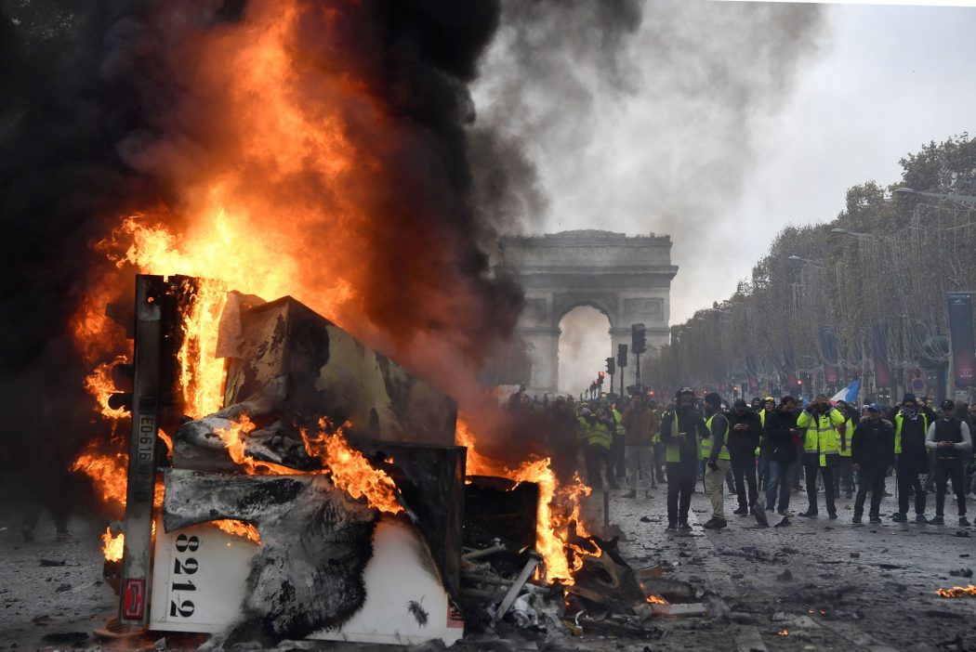
The above picture shows demonstrations where the citizens light fire to show their anger. The political ruling could be dictatorial; therefore, the people are protesting.
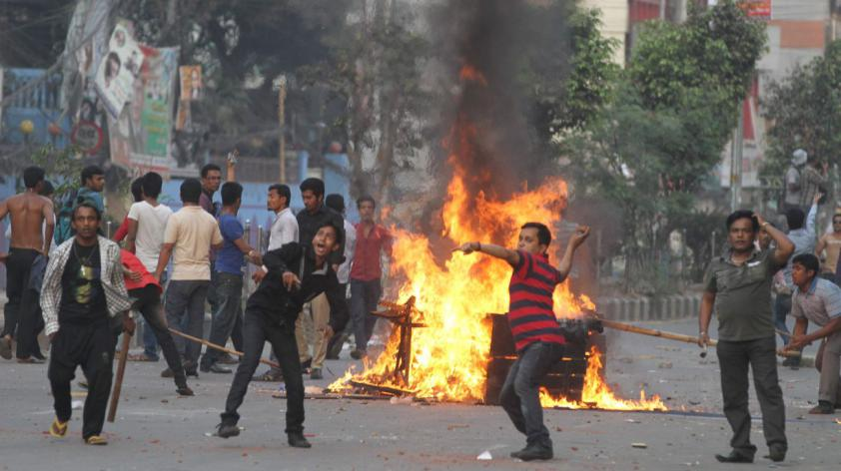
In the above image, one can see people throwing stones most probably to the police. It portrays the anger of the people in an oppressed nation. The art demonstrates a lack of justice, and hence the people have to describe their dissatisfaction with the government.
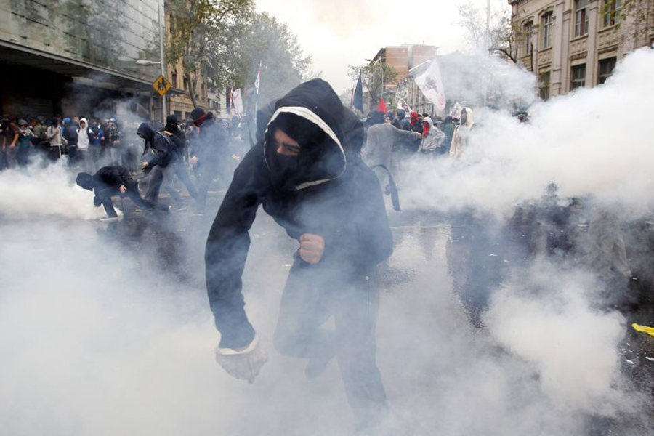
The above image shows the decline of democracy where people have to engage in a battle with the police, thus depicting political violence.
Both art and political violence are not new, and there is plentiful to study from Tolstoy and Collingwood's ideas concerning the subject. If art heals societies influenced by political violence, then it is essential to investigate comprehensively the way such operates (precisely what is expected of the painter) and the reason for that. The other focus of the excursion is looking at the discrepancy between socially cherished art, paralleled to separate art and media practices like main commercial films and television that appear to overstate political violence. That is not to mean that social media is capable of rehabilitating communities, nor is it essential to some extent, only that movies tend to sensationalize vehemence. It becomes a matter of concern rather than fundamentally deal with those subjects. Art may not be intentional for it to play a significant influence on the audience; pure escapism can also heal and assist individuals (Asavei, 622). The main concern of the paper is the art that challenges social encounters unswervingly and its justification for this purpose. The hypothesis of the research is; modern art can be a method of rehabilitating and curing societies influenced by political violence, and it does so, particularly from other media customs whose role is sensationalistic and propagandistic.
Leo Tolstoy's "What is Art?
Tolstoy is against permissive or depraved art and the dehumanization …the separation art from life." According to him, art should communicate the feeling and that it should unite people rather than simply being used for enjoyment or entertainment purpose (Cahn et al., 301). Tolstoy argues that the social worth of art is to talk to the society in a manner that pushes them to a real sense of community. Valuable art is one that communicates emotions and, at the same time, unites people in brotherhood (Spens, 23). When art achieves its potential of bringing individuals together, then it becomes valuable. In more intensity later, then we will discuss George Gittoes and Anita Glesta concerning Tolstoy when applied mainly to matters of political viciousness and painful joint experiences. The purpose of the sculptor is more important and worthy of enhancing society's sense of camaraderie and support.
Collingwood's "The principles of Art."
According to Collingwood, the artistic surroundings need to be collaborative, engaging the audience and other artists. Art, poetry inclusive, is language, and their worth lies in its communicative nature of emotions between the society and the artist. The artist learns from other artists and gets motivation from society. The artist acts as the spokesperson for the nation. Art is naturally collaborative, and it offers the perfect way of experience sharing and unites individuals together. The artist represents the heart of society. The community itself cannot understand its heart. Many authors have been examining the works of Collingwood concerning the meaning and notion of art. T.S Elliot's "The Waste Land," wrote responding to the destruction of the First World War and associated disaster in London at the time (Various Authors, 26). His poem looks at the resultant societal trauma whereby he sees the decay that the civilization is encountering, as depicted in his poetry. The artist's encounters and feelings shaped the interest of Collingwood. His method of association between the experience of the artist and the empathy of the audience were intrinsic (Knight, 374). The social challenges influenced Tolstoy to write about "What is Art?" and it is fascinating to link the works to the modern political ferocity and social difficulties instances comparable to those they were intially writing about in a bid to manage the conflicts(Spens, 26). There is little research in art theory concerning how significant and potentially essential ideas associate with contemporary challenges and art. Based on Collingwood and Tolstoy's ideas, such becomes problematic because the two agree that a competent artist should influence social collaboration and brotherhood. The artist should not invite his or her society to be overly engaged in the creation of art.

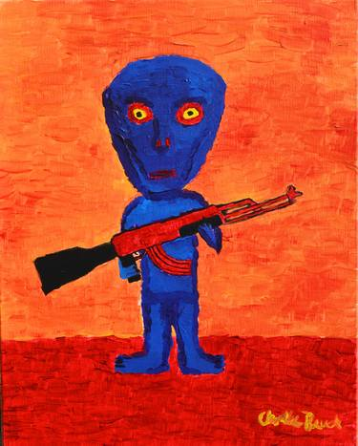
The above picture shows the dictatorship, and it indicates dictatorship where the use of force has to be applied

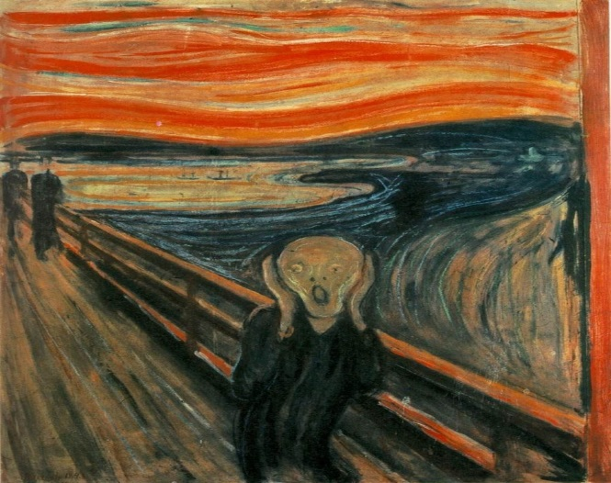
The above picture shows the anguish that people experience as a result of political violence.
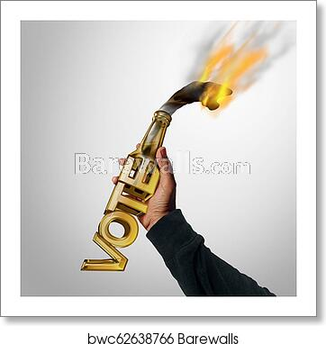
The above art is a call for people to elect good leaders who value humanity. It seeks to end political violence that arises due to poor governance.
Methodology
The survey will rely on interviews with two present essential artists. They regard the matter of political viciousness in very diverse methods where they offer evidence for the hypothesis.
Participant 1: Anita Glesta
The artist resided in New York City and observed the 9/11 extremist assaults on the Twin Towers, hastening her interrogation of the artist's function in the twenty-first century. The artist decided to examine Picasso's iconic art and, having functioned with survivors of 9/11, had consultations with Guernica genocide survivors to explore an analogous encounter between the two occurrences and the involved societies' influence.
Participant 2: George Gittoes
The artist has been in diverse war regions in over the last forty years, including South Africa, Lebanon, Iraq, and Afghanistan. Gittoes paintings are big and usually show different instances of horrors he encountered or which have been communicated to him in the war areas he went to. Gittoes has made films about artists in various conflict areas and has interests in using the art to escape from one situation to another. In his work, Gittoes seeks to uncover political violence together with the uselessness insanity of the War (Dillon, 1). The "Bullets of the Poets" are part of the works he has used together with "The Miscreants of Taliwood and other large figurative canvases. Political violence and War dominate his works, although his body of work is extensive and wide-ranging.
Rationale
The reason for choosing the two artists from the interview is because they both have interests is in political violence as a topic that they handle in several measures. The two artists retorted to characteristics of the War on horror. Glesta did this by dealing with the Twin Towers violence survivors and the concerns of societal trauma because of political violence in her work. On the other side, Gittoes covers numerous war districts, and political fierceness acts, comprising of the War on terror impacts on militaries and civilians in Afghanistan and Iraq. Interviewing the artists who are so different will help uncover the common causes that make considerable modern art socially liable, and in doing so, arrive at suppositions concerning what features make art to be socially answerable across the contemporary practice panel. The beneficial approach for the interview was through email. Both artists had similar questions to ensure that the author compared the answers more concisely.
Results
The focus of the study was to highlight specific insights, problems, and probable challenges in the purpose and employment of art in rehabilitating and healing populations. It also aimed at gaining understanding into the variance between present-day uses of the art of the issue of political fierceness from the artist's view compared to coverage of social media. It examined the particular methods that modern art can be therapeutic and rehabilitative by designating to the participants' art exercise. The critical emerging perceptions were the work of the artist and social accountability, public, and violent portrayal, which are deliberated first regarding Anita Glesta's interview and secondly with that of George Giettos.
Anita Glesta
Artists' work and social responsibility
Glesta seems not to trust the ferocious or political appearance and its peculiar propagandistic nature. She argues that an artist has fascinating methods of being treasonous. A painter can be an activist without having a political narrative engagement. Glesta says that there is no conviction that art can or cannot task in any given way. She considers that art is for the sake of art but views art as having healing abilities and sees such as a positive influence. To Glesta, art can be useful, and for her as an artist, she has an ethical duty in giving back to the community through art, which regards a gift she is proud of. Glesta trusts that art is vital in its central imaginative attractiveness and goodness, together with the capability of showing the human experience universality.
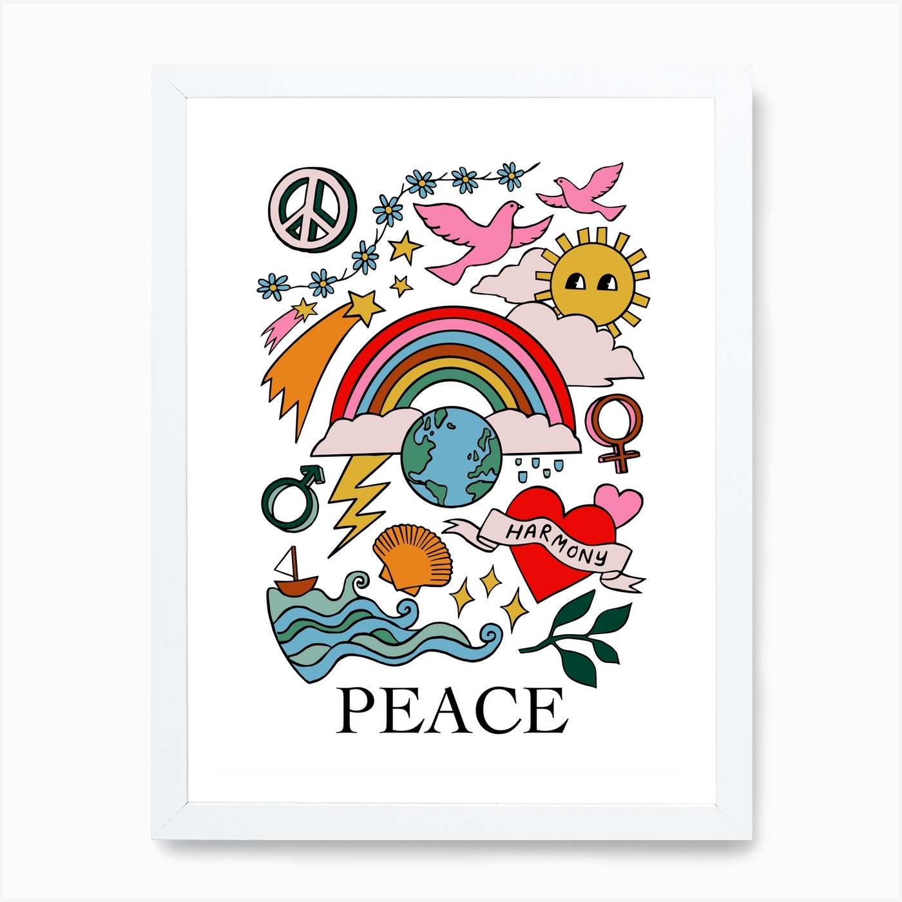
The above art advocates for peace in society
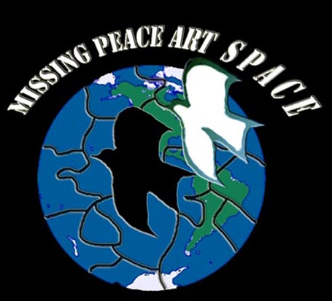
The above picture advocates for peace.
The comic picture above shows victory.

Community
Glesta sees art as a discourse and contemplates it essential in itself rather than a planned therapy for the complications in society (Petty). The two effects have an interrelation, and she regards such as a positive consequence of her art encounter.
Depiction of violence
According to Glesta, using oral narratives rather than images is better because humanity has been blasted with ferocious pictures, which has made societies numb. Whether the violence is intentional or not, it ends up exaggerated and sensationalizes because of the profitable nature of the art domain (Bishop, 46). Glesta feels that art does not communicate horror and trauma in art because visual art could work as well as engraved and oral messages.
George Gittoes
Artists work and social responsibility
In making art, sympathy is a dominant initiative, and Gittoes has a high influence from the reactions of viewers of his work. By being compassionate, art can have moral and social responsibilities and be useful regardless of the art world, often being commercially driven. Creating comic instances helps people have relief of their problems from the traumatizing aspects of War. The perception of his part as an artist is political, where he considers that art and movie that generate the myth of the political killer hero that ultimately disseminates War.
Community
Gittoes has been working as an art counselor in a mental facility, and he trusts that art is significant in transforming people. In his film, "artists in the Jalalabad using their skills to effect social change and work to a better and more equal Afghanistan by artistic means" shows an example of how he encourages youngsters to be inventive.
Depiction of violence
Gittoes' work is full of violent images, although he does not contemplate it complimentary. He sees it as vital in exposing the real traumatizing nature of War and violence. In the Taliban's film, there is an execution of a child, and the utilization of the films pacify and close other film industries in Afghanistan; he portrays violence. Giettoes does this with an effort to expose the horror movies of the Taliban and the political organization behind them. Similarly, he employs horrific pictures in his portraits to represent the suffering that individuals encounter during the War.
The use of fervently stimulating pictures and stories in images and movies by Giettoes is an example of the communication of emotions and experiences that Tolstoy advances in his differentiating between publically vindicated and dissolute art (Mihai & Thaler, 2019). There is a difference in the genuineness of the communication and the truth of understanding.
Both artists confirm the hypothesis by agreeing that socially treasured modern art is divergent from other systems of broadcasting that are manipulative. However, they had slight distinct notions concerning how that difference can be prepared. The outcomes also support the standpoint that modern art is vital as a way of rehabilitating and healing societies. The artistic work of the artists had examples of remedial and rehabilitative influences on the cultures they were involved in regardless of the different notions about violence depiction and actual integration with societies. Such reinforces the idea that art can heal and unite people even if it did not mean to do so.
Conclusion
Art is different from other media forms and helps in healing and giving hope to communities. In the research, there has been an exploration of the ideas of Collingwood and Tolstoy using modern instances. There was discussion of diverse ways of social engagement pointing ultimately to the deduction that the artist's purpose and definite social involvement do not primarily regulate social worth and influence on public backing up Collingwood's theory of art and social accountability more than of Tolstoy. From the discussion, it is clear that current art can be socially valued, whether purposefully or not, and whether alongside other political engagement or not. Such indicated the potentials that modern artists have in engaging with matters of political fierceness and the concern about the importance of art in that perspective. Further study should focus on understanding the value that the communities influenced by political vehemence give to the healing and the rehabilitation process from art.

Works Cited
Asavei Maria Alina. "The art and politics of imagination: remembering mass violence against women." Critical Review of International Social and Political Philosophy 22.5 (2019): 618-636.
Bishop, Claire. Artificial hells: Participatory art and the politics of spectatorship. Verso Books, 2012.
Cahn, Steven M., Stephanie Ross, and Sandra L. Shapshay, eds. Aesthetics: A comprehensive anthology. John Wiley & Sons, 2020.
Čičovački, Predrag. "Leo Tolstoy on the Purpose of Art." Philotheos 19.1 (2019): 116-124.
Dillon, Noah. "GEORGE GITTOES: Witness to a War." The Brooklyn Rail (2011).
Knight, Christopher J. "The Letters of TS Eliot, Volume 3: 1926—1927." (2013): 369-376.
Mihai, M., & Thaler, M. (2019). Political violence and the imagination: an introduction.
Petty, Erin. "Anita Glesta Creates Census-Themed Public Art Project." Washington City Paper. 2010. Retrieved from https://www.washingtoncitypaper.com/arts/blog/13073639/anita-glesta-creates-census-themed-public-art-project
Spens, Christiana. "Contemporary art and political violence: the role of art in the rehabilitation and healing of communities affected by political violence." Journal of Terrorism Research (2013).
Various Authors, J. T. R. "Journal of Terrorism Research, Vol 4, Issue 1." Journal of Terrorism Research (2013).

